De Martonne Aridity Index

**Introduction**

Aridity is a measure of degree of dryness or lack of moisture, to which a climate lacks effective, life-promoting moisture; the opposite of humidity, in the climate sense of the term (American Meteorological Society, 2006). A region is arid when it is characterized by a severe lack of available water, to the extent of hindering or preventing the growth and development of plant and animal life. Environments subject to arid climates tend to lack vegetation and are called xeric or desertic.

The distribution of aridity observed at any one point in time is mainly the result of the general circulation of the air atmosphere and/or precipitation. The former does change significantly over time through climate change.

De Martonne Aridity Index is applicable locally. A measure of aridity of a region, proposed by De Martonne (1925), which takes into account annual mean precipitation (mm) the annual mean air temperature (°C).

**Methodology**

A measure of aridity of a region, proposed by De Martonne (1925), is given by the following relationship:

$$I_{DM}= \frac{P}{T+10}$$

Where P is the annual mean precipitation (mm) and T (°C) the annual mean air temperature. An increase in the value of IDM, at constant temperature, implies an increase of precipitation. The De Martonne index climatic classification based on the values of IDM and P is shown in the following table.

|  |  |
| --- | --- |
| Value of $I_{DM}$ | Climate |
| $$I_{DM}<5$$ | Hyper-arid |
| $$5{≤ I}_{DM} ≤ 10$$ | Arid |
| $$10{≤ I}_{DM} ≤ 20$$ | Semi-arid |
| $$20{≤ I}_{DM} ≤ 24$$ | Mediterranean |
| $$24{≤ I}_{DM} ≤ 28$$ | Sub-humid |
| $$28{≤ I}_{DM} ≤ 35$$ | Humid |
| $$35{≤ I}_{DM} ≤ 55$$ | Very humid |
| $$I_{DM}>55$$ | Extremely humid |

**Result and discussion**

|  |  |  |  |  |  |
| --- | --- | --- | --- | --- | --- |
| Year | Bogura | Dinajpur | Ishwardi | Rajshahi | Rangpur |
| 1966 | 2.8671 | 3.549641 | 2.429451 | 3.974939 | 2.935495 |
| 1967 | 3.40162 | 3.740322 | 3.248624 | 2.674936 | 4.10972 |
| 1968 | 3.895521 | 4.350953 | 2.504138 | 3.474068 | 4.819075 |
| 1969 | 3.588421 | 4.792257 | 4.354496 | 5.478048 | 5.608632 |
| 1970 | 4.19061 | 3.361285 | 3.405147 | 3.509957 | 4.783806 |
| 1971 | 4.225653 | 4.011955 | 3.403104 | 4.178896 | 3.772999 |
| 1972 | 2.908794 | 2.819611 | 2.205934 | 2.137387 | 3.560845 |
| 1973 | 5.892272 | 4.111349 | 5.833627 | 4.470918 | 5.360652 |
| 1974 | 4.395448 | 4.111349 | 3.748229 | 4.024108 | 4.819075 |
| 1975 | 3.346576 | 4.111349 | 4.201287 | 2.657067 | 4.224778 |
| 1976 | 4.40801 | 4.110371 | 6.170766 | 3.295612 | 4.541098 |
| 1977 | 3.451575 | 4.111349 | 6.43662 | 4.448568 | 4.83585 |
| 1978 | 4.456535 | 4.111349 | 3.311511 | 4.104628 | 5.10107 |
| 1979 | 5.08796 | 4.111349 | 3.597272 | 3.577536 | 5.051178 |
| 1980 | 3.755083 | 4.115756 | 3.397107 | 3.662135 | 5.072377 |
| 1981 | 4.103835 | 5.019561 | 5.336985 | 5.263034 | 4.596929 |
| 1982 | 2.871229 | 3.217068 | 2.940969 | 2.567505 | 5.281977 |
| 1983 | 4.154135 | 5.098944 | 3.944685 | 3.822149 | 5.445918 |
| 1984 | 5.415638 | 5.244671 | 3.972859 | 3.687229 | 9.068473 |
| 1985 | 3.944548 | 4.98455 | 2.728431 | 2.915017 | 6.927885 |
| 1986 | 5.018173 | 4.688777 | 3.497768 | 3.533404 | 5.625304 |
| 1987 | 4.649659 | 7.625164 | 3.897831 | 3.594129 | 7.618366 |
| 1988 | 5.205321 | 5.254317 | 3.600419 | 3.348816 | 5.975379 |
| 1989 | 3.303718 | 4.595244 | 2.932987 | 3.115082 | 4.514423 |
| 1990 | 4.848273 | 4.98682 | 4.943476 | 4.171098 | 5.98556 |
| 1991 | 5.364711 | 4.822049 | 3.965396 | 3.506843 | 5.922097 |
| 1992 | 3.18648 | 3.964419 | 2.481616 | 1.959136 | 4.819798 |
| 1993 | 4.465769 | 5.22542 | 3.758657 | 3.770185 | 6.067903 |
| 1994 | 3.104685 | 2.70136 | 2.470862 | 2.658596 | 3.098726 |
| 1995 | 5.233623 | 6.195614 | 2.973098 | 3.315199 | 6.450536 |
| 1996 | 4.447523 | 3.756213 | 3.311304 | 2.934104 | 4.756705 |
| 1997 | 3.058298 | 4.325681 | 4.432381 | 4.85462 | 4.771242 |
| 1998 | 6.011093 | 5.655825 | 3.801115 | 3.559459 | 5.621583 |
| 1999 | 3.689699 | 5.940501 | 4.015125 | 4.25892 | 6.892416 |
| 2000 | 4.294393 | 3.576032 | 4.222819 | 3.900958 | 4.181644 |
| 2001 | 3.232019 | 5.229649 | 3.437609 | 3.161679 | 5.898225 |
| 2002 | 4.694759 | 6.039569 | 3.257549 | 3.357749 | 6.178823 |
| 2003 | 3.966245 | 4.940555 | 2.575669 | 3.285631 | 5.758811 |
| 2004 | 5.036778 | 5.487615 | 4.152257 | 4.140489 | 6.41225 |
| 2005 | 4.840838 | 7.059801 | 4.185939 | 3.237327 | 6.795284 |
| 2006 | 2.538735 | 3.023529 | 2.951234 | 2.625846 | 3.963242 |
| 2007 | 4.460198 | 3.74348 | 3.650499 | 4.690841 | 4.843081 |
| 2008 | 4.15883 | 4.205031 | 3.029036 | 3.058495 | 4.547514 |
| 2009 | 3.241752 | 4.759107 | 2.962963 | 2.3933 | 5.218927 |
| 2010 | 2.962946 | 3.894948 | 2.092782 | 1.844485 | 5.021647 |
| 2011 | 4.107998 | 3.973373 | 4.161762 | 3.44091 | 4.664574 |
| 2012 | 2.685231 | 3.636411 | 2.522731 | 2.744187 | 4.537525 |
| 2013 | 2.890831 | 4.390435 | 2.701853 | 2.949461 | 4.583529 |
| 2014 | 4.025122 | 3.359512 | 3.431915 | 2.808941 | 3.91131 |
| 2015 | 3.719276 | 4.698479 | 3.753005 | 3.343786 | 5.780937 |
| 2016 | 2.496507 | 3.91886 | 3.070015 | 3.19842 | 5.103425 |

**Analysis of indices for Bogura**

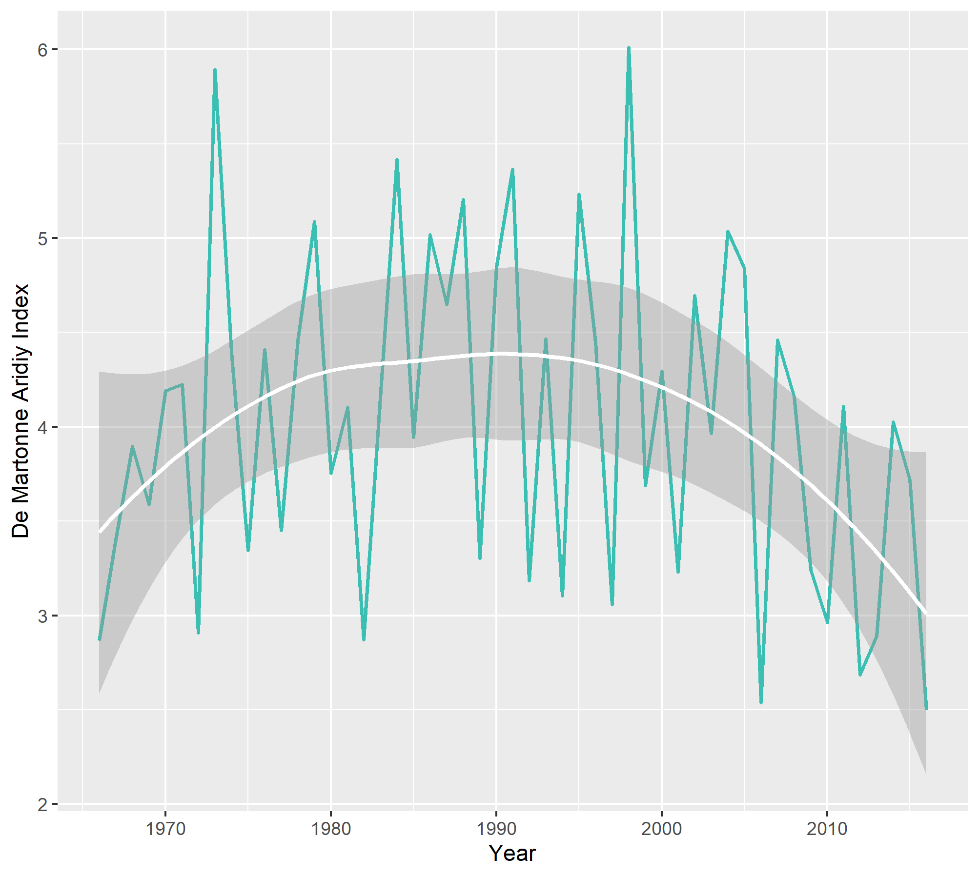

**Figure 01: De Martonne Aridiy Index for Bogura for the years 1966-2016**

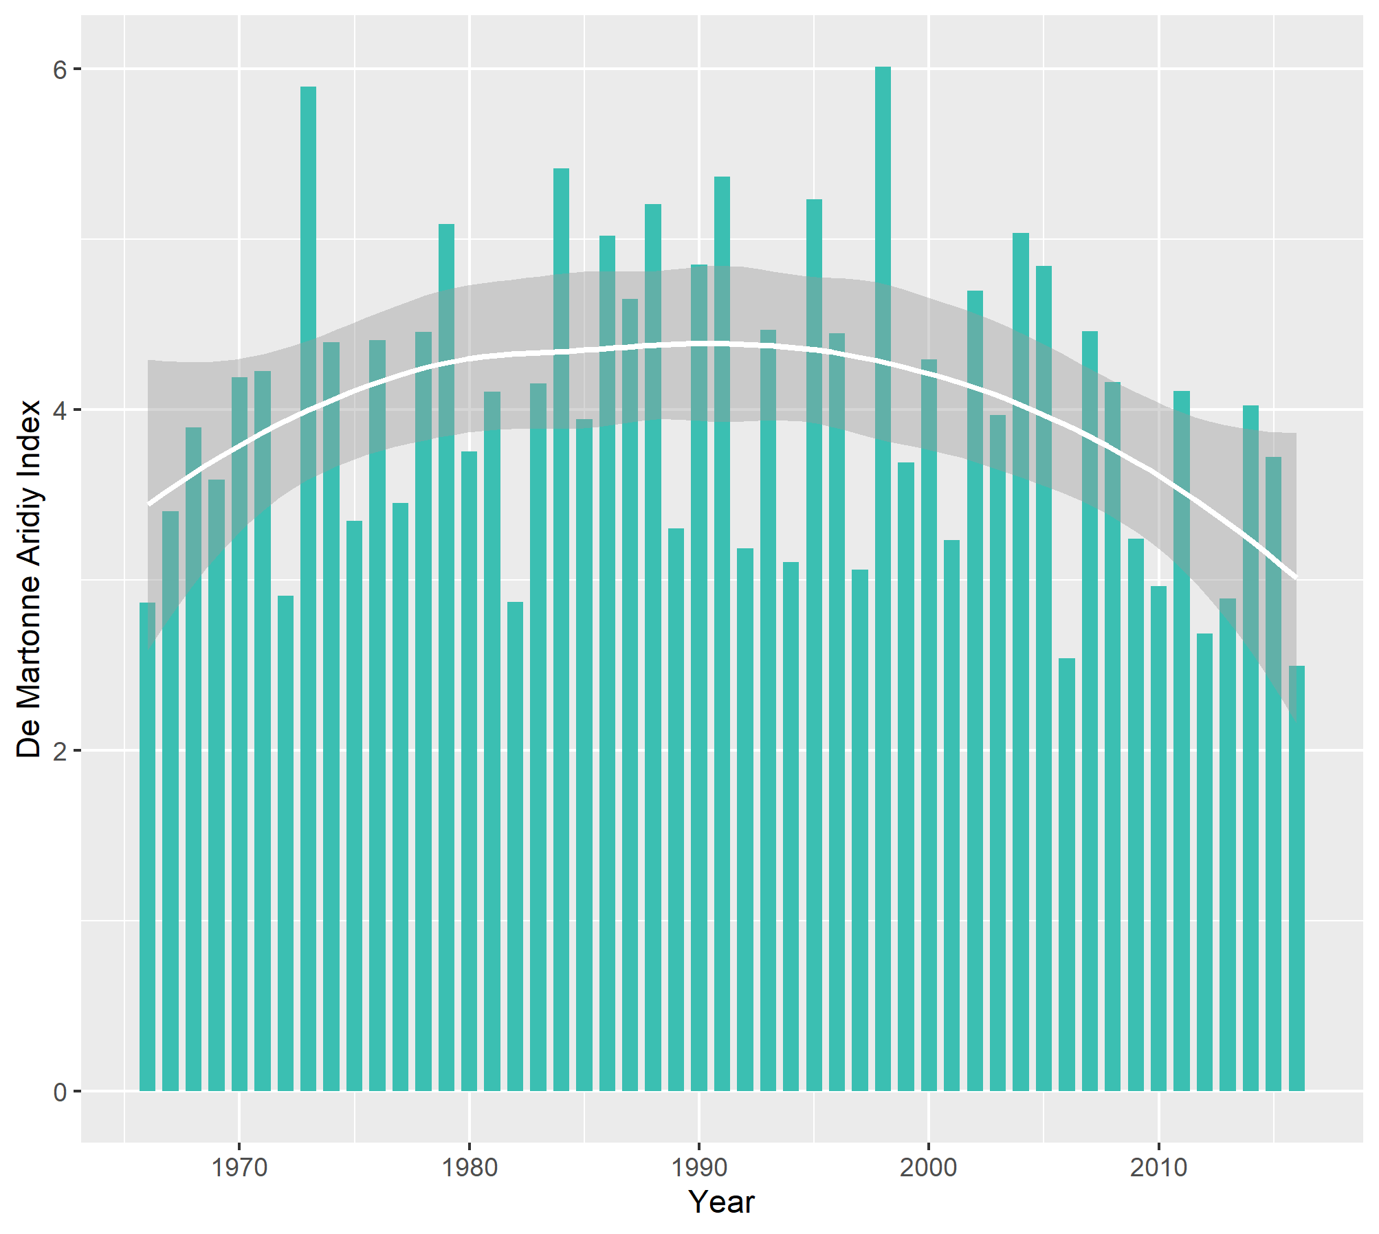

**Figure 01: De Martonne Aridiy Index for Bogura for the years 1966-2016**

As evident from the preceding plots, according to De Mortonne aridity index, drought existed in Bogura for all through the study years (since 1966 until 2016) since none of the indices exceed 10. Even as many as 42, out of 51, years are classified as hyper-arid since the value of the index was below 5 for those years. Another significant finding is that the values show a recent decreasing trend, which further implies a tendency toward more dry periods.

**Analysis of indices for Dinajpur**

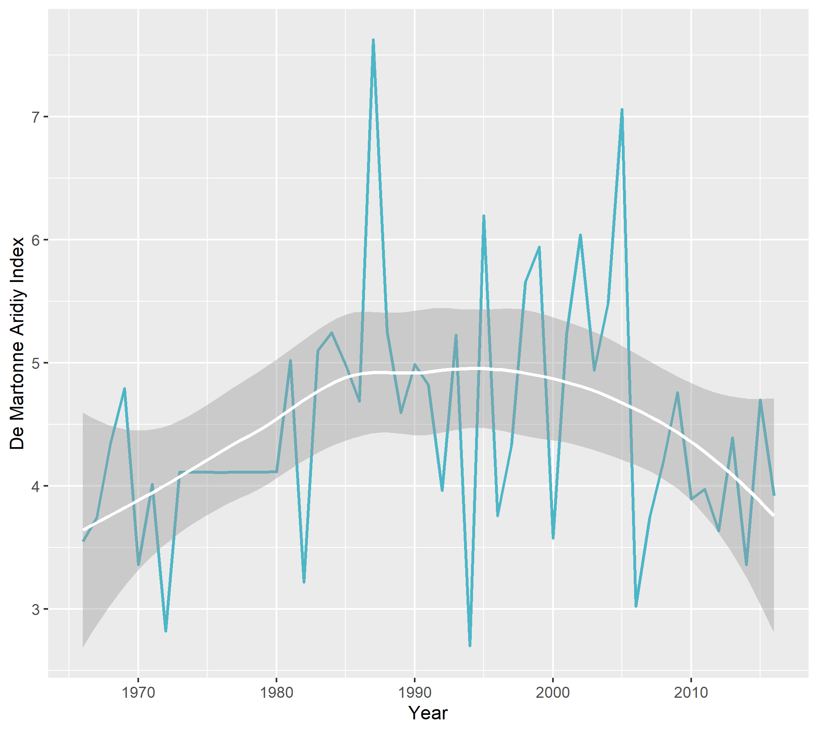

**Figure 02: De Martonne Aridiy Index for Dinajpur for the years 1966-2016**

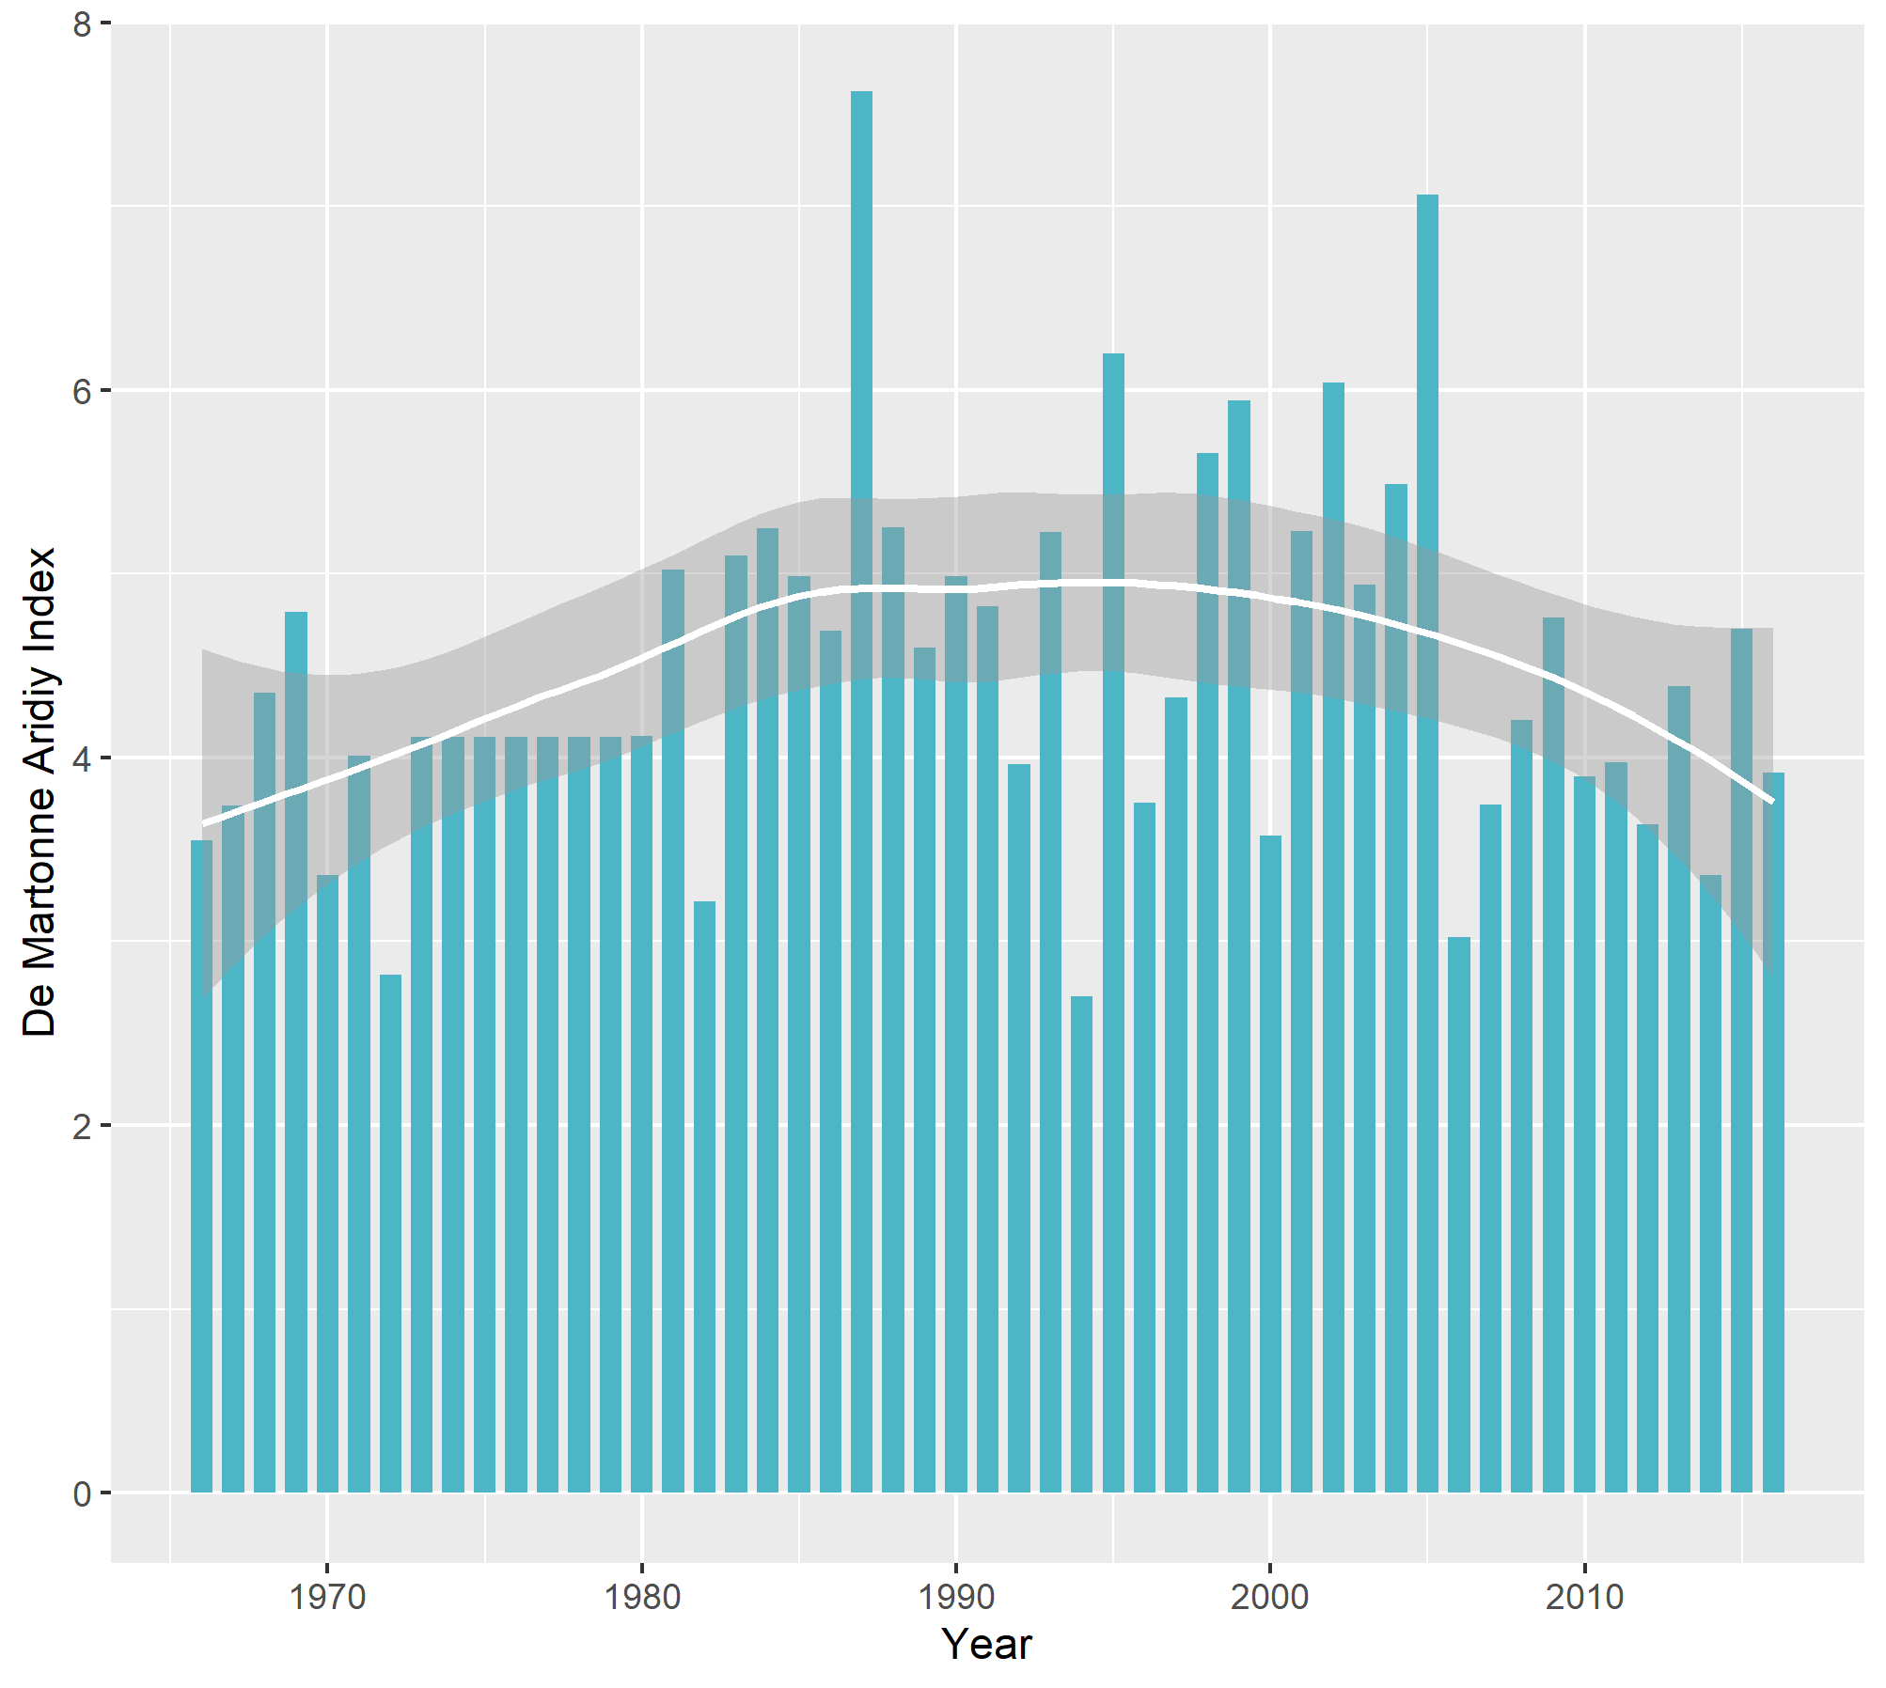

**Figure 02: De Martonne Aridiy Index for Dinajpur for the years 1966-2016**

Since neither of the indices exceeds even 8, all the years imply drought. Nevertheless, 38 years are classified as hyper-arid, which are 75% of the total study periods, while no year has been classified as Mediterranean or closer to wetness. Although the indices had a positive trend before and after 2000s, they are, of late, have a downward trend indicating proneness toward drought.

**Analysis of indices for Ishwardi**

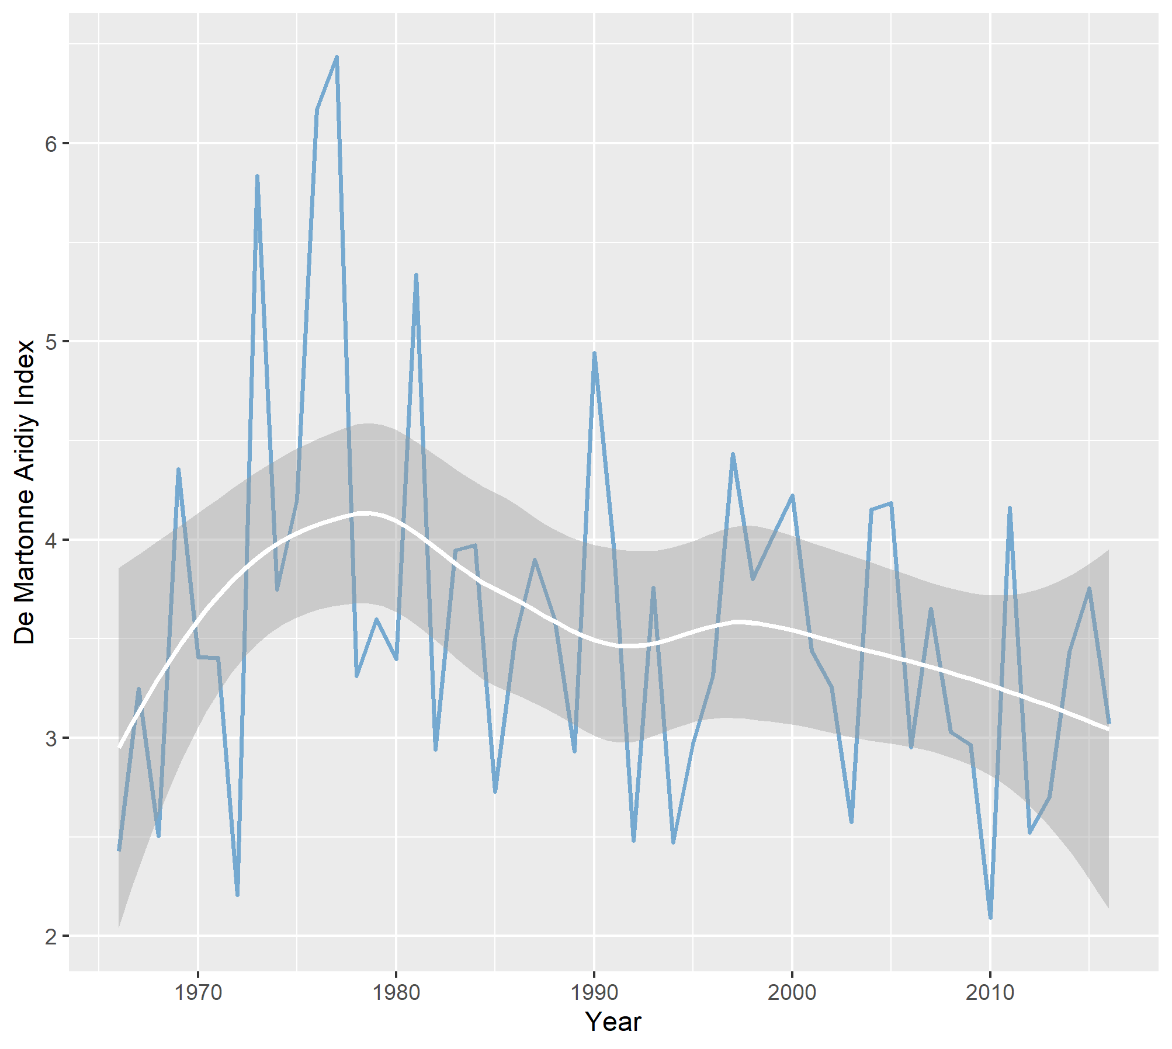

**Figure 03: De Martonne Aridiy Index for Ishwardi for the years 1966-2016**

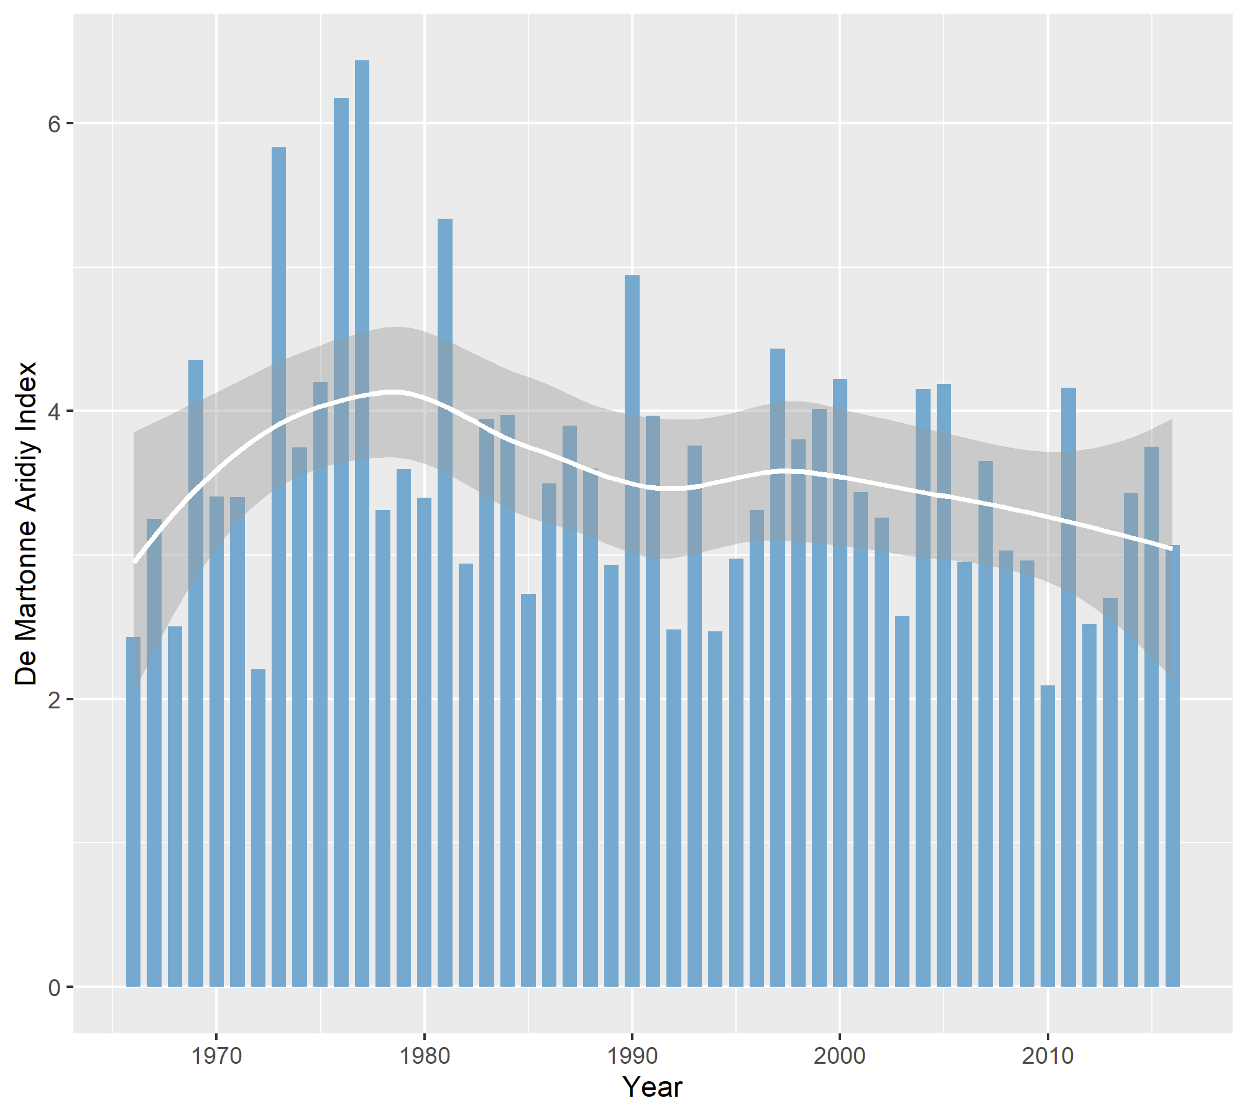

**Figure 03: De Martonne Aridiy Index for Ishwardi for the years 1966-2016**

All the indices for the Ishwardi region are well below 7, indicating all years being classified as dry or hyper-dry. After 1980s, the values are non-increasing, which implies the condition of drought is deteriorating. Moreover, as many as 42 years are classified as hyper-arid, which are more than 92 % of the total study years.

**Analysis of indices for Rajshahi**

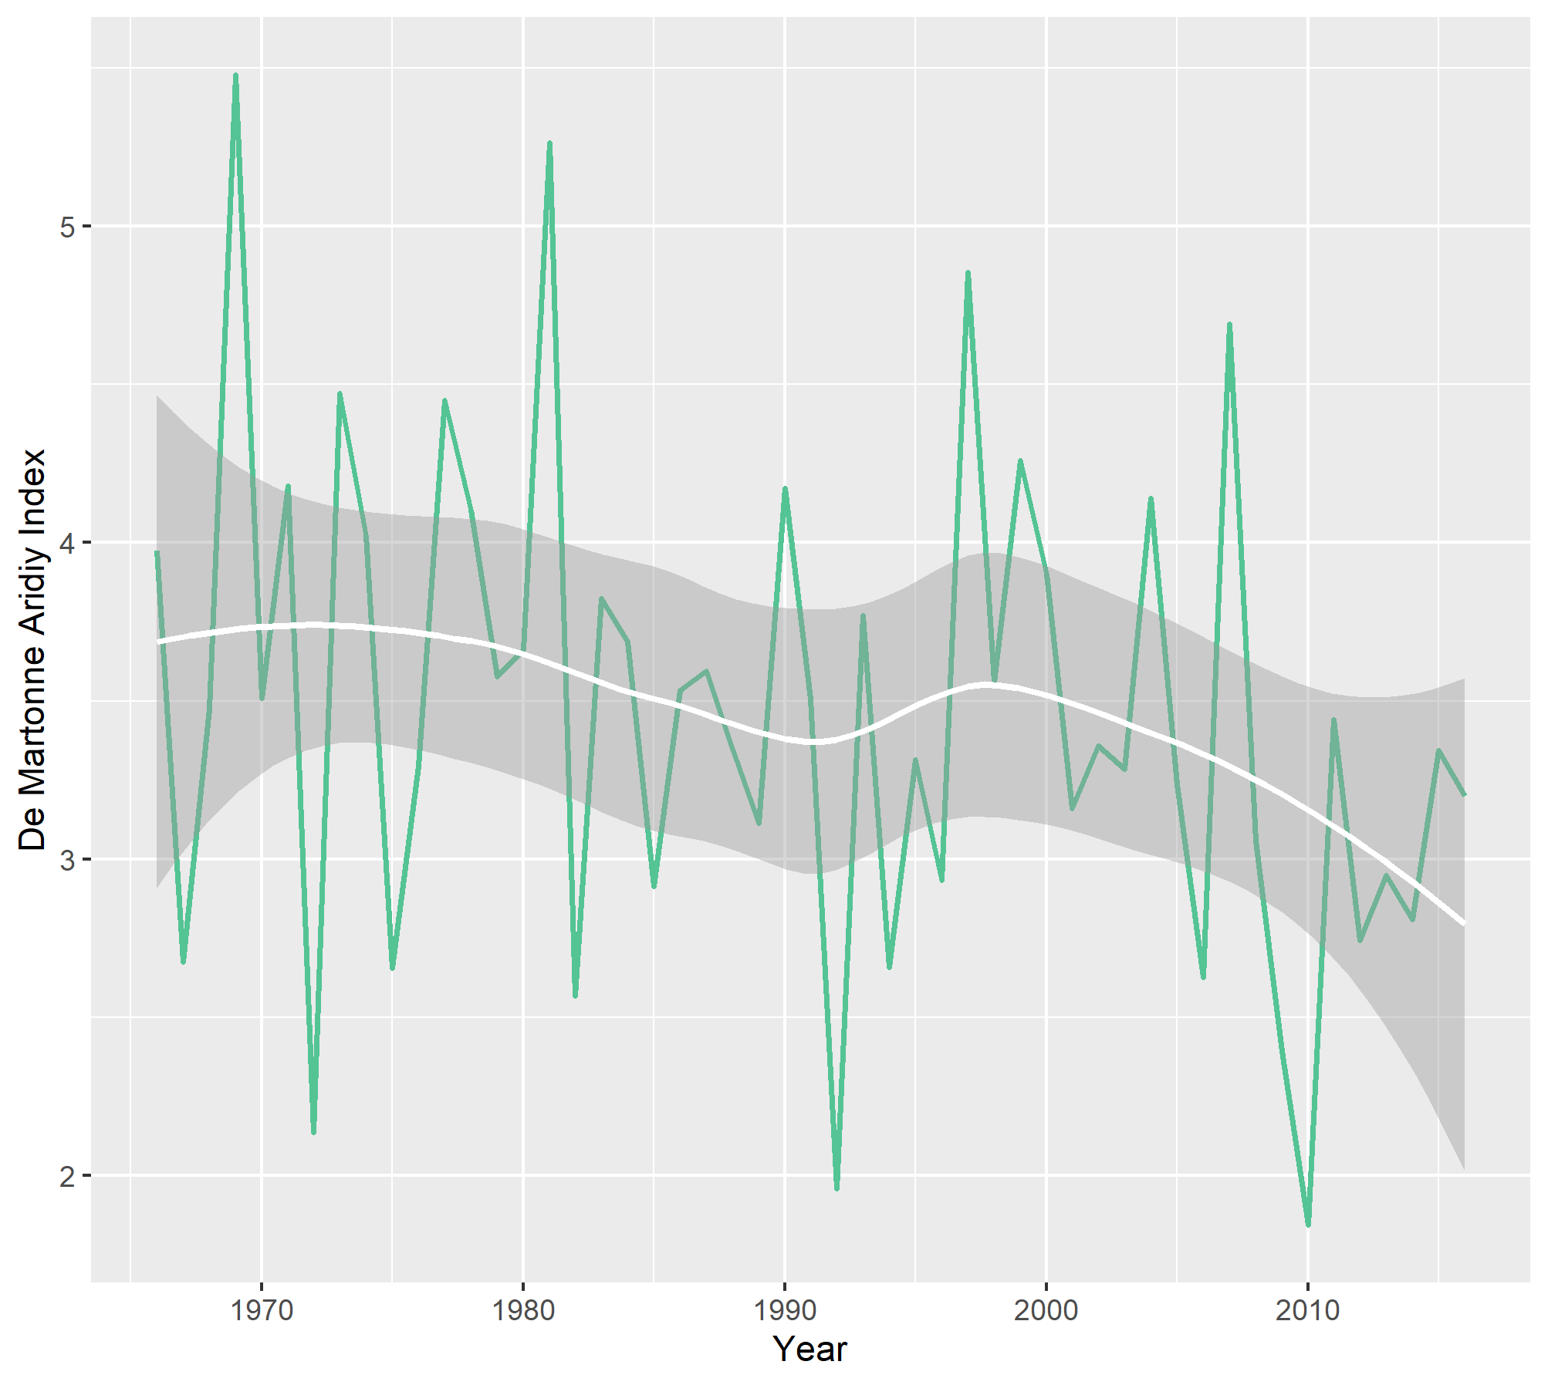

**Figure 04: De Martonne Aridiy Index for Rajshahi for the years 1966-2016**

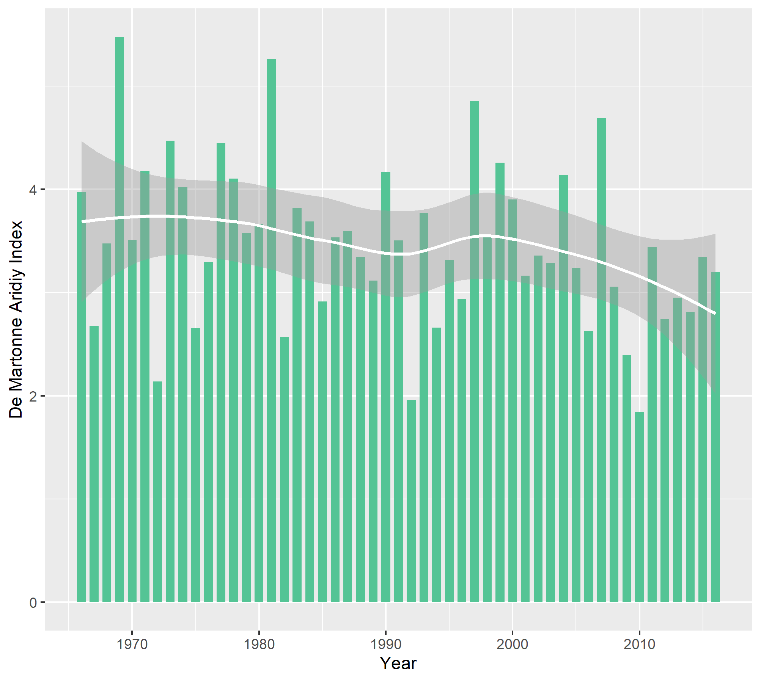

**Figure 04: De Martonne Aridiy Index for Rajshahi for the years 1966-2016**

No values of De Mortonne aridity index exceed even 5, which classify all the years studied as hyper-arid. Moreover, the indices have a decreasing trend, further deteriorating the drought situation.

**Analysis of indices for Rangpur**

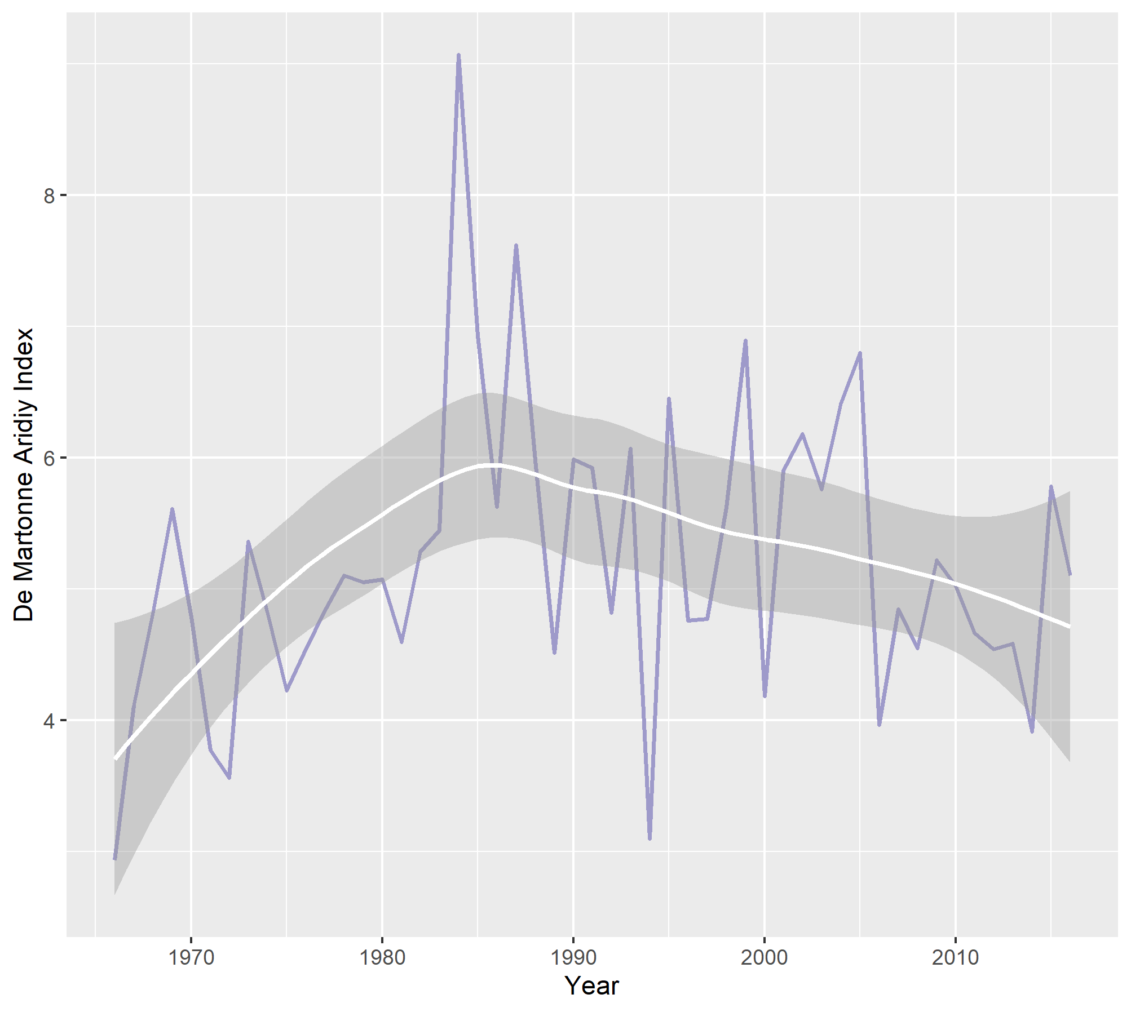

**Figure 05: De Martonne Aridiy Index for Rangpur for the years 1966-2016**

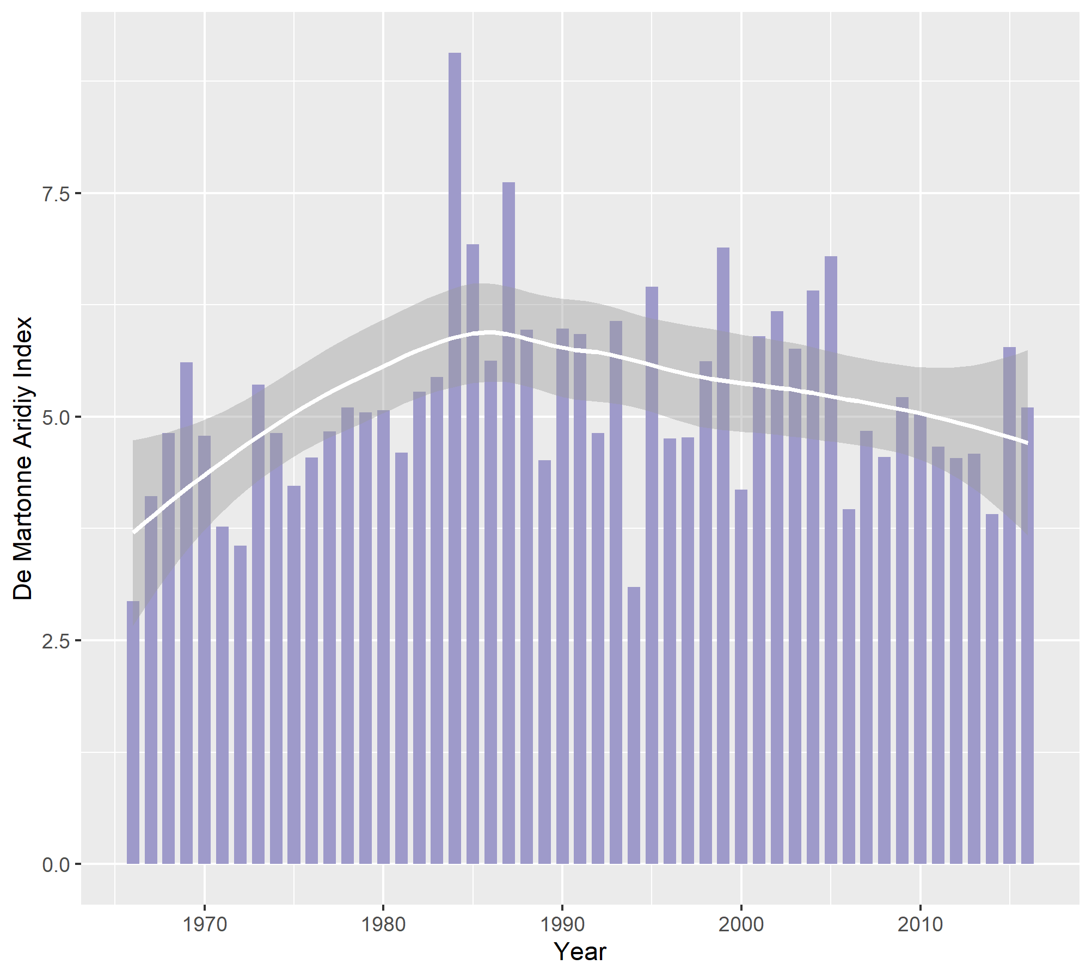

**Figure 05: De Martonne Aridiy Index for Rangpur for the years 1966-2016**

The value of the indices barely exceed 8, that is all the values are well below 10, implying that all study years are either arid or hyper-arid. Since the values below 5 classify the corresponding year to be hyper-arid, there seem to be a number of such years. It turns out there are 24 years, out of total of 51, being almost 50% of total study period, which are classified as hyper-arid.

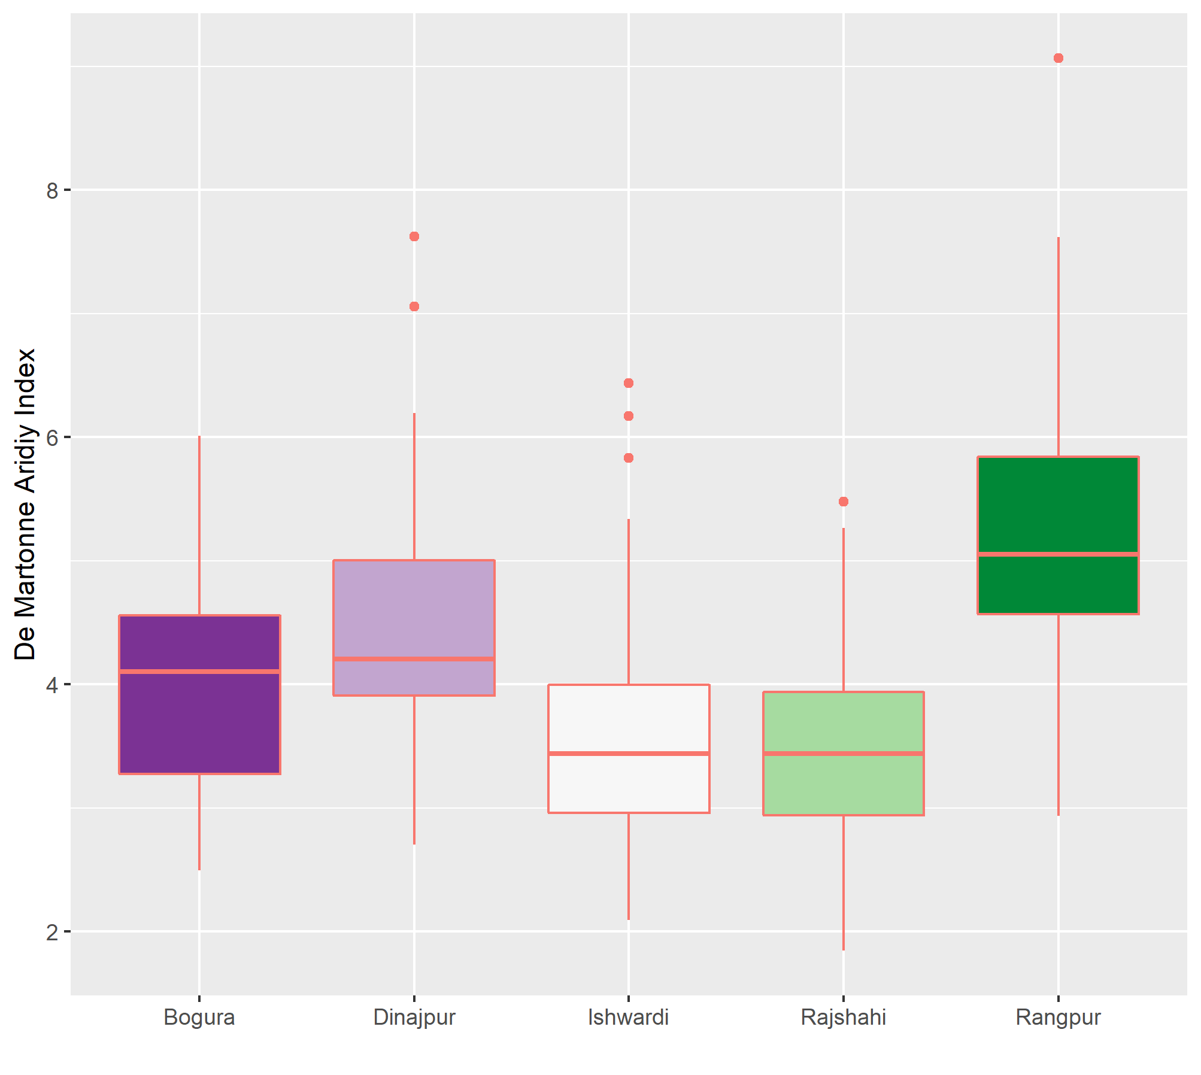

The boxplot implies that driest regions are Ishwardi and Rajshahi, of the two Rajshahi being a bit drier. The latter has only one outlying index, while in the case of Ishwardi 3 values are possible outliers, which implies the latter is less prone to drought than Rajshahi. Of the rest, Rangpur region is the least dry, the value of index being as high as almost 9 and most of the values are well over 5, classifying the corresponding years as dry, rather than hyper-arid.